- Select Quick Statistics in the tab along the top
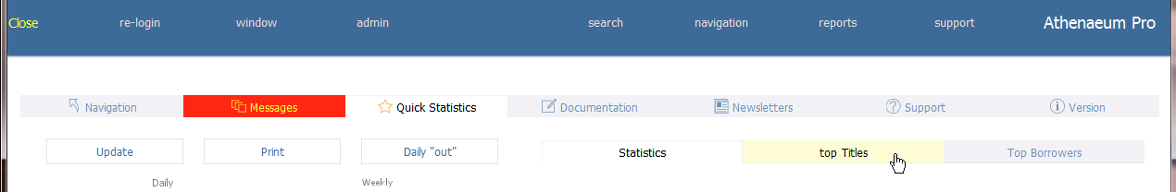
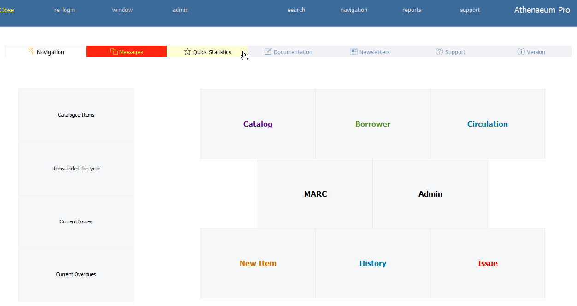
- Select Top Titles in the tab along the top
- Voila!
